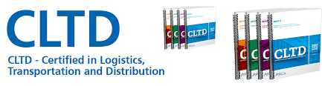
Certified in Logistics, Transportation, and Distribution (CLTD)
In Logistics there is a saying that “Devil is in the Details. There is No Silver Bullet.”
However, the CLTD can act as “Your Silver Bullet or calling card leading to a better career, more money, and peer recognition. Like the Lone Ranger did in the Old West it demonstrates your enduring value to others and shows that you have what it takes to succeed.
The APICS CLTD is designed for any aspiring professional in the Supply Chain field across all industries.
APICS is the premier professional association for supply chain and operations management and the leading provider of research, education and certification programs that elevate supply chain excellence, innovation and resilience.
The APICS Certified in Logistics, Transportation and Distribution (CLTD) designation provides a comprehensive body of knowledge, best practices and standards for those in the logistics, transportation and distribution industries. The APICS CLTD designation serves the needs of both professionals and employers around the world by reducing the impact of industry skills gaps as well as assisting employers in developing the personnel needed to meet customer demand and impact bottom-line results
The CLTD designation will help you:
- Master the essential knowledge needed for today’s supply chain industry.
- Expand your outlook on the logistics field and enable you to bring new ideas to your organization
- Remain current with global logistics trends and developments
- Boost your confidence as a logistics expert.
- Provide you with the tools you need to help reduce costs and increase customer satisfaction
ELIGIBILITY:
CLTD Certification requires that candidates have one of the following three criteria 1) 3 years of related business experience OR 2) Bachelor’s degree or the international equivalent OR 3) CPIM, CSCP, CTL, CFPIM, CIRM, SCOR-P, C.P.M., CSM or CPSM designations.
COURSE DETAIL:
The CLTD is a comprehensive program that provides professional development and exam preparation. The program combines classroom work along with print and computer based learning activities. Your learning system comes complete with 4 books as illustrated.
The program is organized into 8 modules that will cover best practices in the day-to-day functions of logistics professionals to drive improvement in distribution and transportation, maximize efficiency and impact the bottom line.
- Logistics and Supply Chain Overview
- Capacity Planning and Demand Management
- Order Management
- Inventory and Warehouse Management
- Transportation
- Global Logistics Considerations
- Logistics Network Design
- Reverse Logistics and Sustainability
CLASSES: The PAN-APICS chapter is offering classes this fall in the evenings from 630pm-930pm.
FALL: Sept 26,28--Oct 10,12--Oct 24,26(Tues, Thurs) - Oct 30 & Nov 1(Mon, Wed), Nov 7,9—Nov 28,30 Dec 5,7 (Tues, Thurs)—Video & Sample Exam Dec 12.
LOCATION: Rowan College at Burlington County (RCBC)
900 College Circle, Evans Hall, Rooms 219 A/B
Mount Laurel, New Jersey 08054
Phone: (856) 222-9311 WWW.RCBC.EDU (see below map)
INSTRUCTOR: Daniel N. McAuliffe, CTL, DLP, CLTD. VP of Transportation & Distribution, PAN-APICS
COST: $1995 for APICS PLUS members------$2295 for Non-members.
Note: To get the discount you must register with APICS as a “Plus” member and provide proof of registration. Do this on WWW.APICS.ORG and choose PAN-APICS as your chapter.
Joining APICS has its own rewards as you develop new contacts, attend professional development meetings, keep up on latest news with APICS magazine, Enjoy discounts on local events and seminars, and discounted registration for the APICS annual conference.
Books and materials will be handed out on the first day of class.
Upon completing this course you will be ready to take the exam which is a separate fee. The exam eligibility application must be submitted and approved before the exam can be taken.
Register directly with PAN-APICS at www.pan-apics.org.
Move with the speed of a “Silver Bullet” and Register Now!

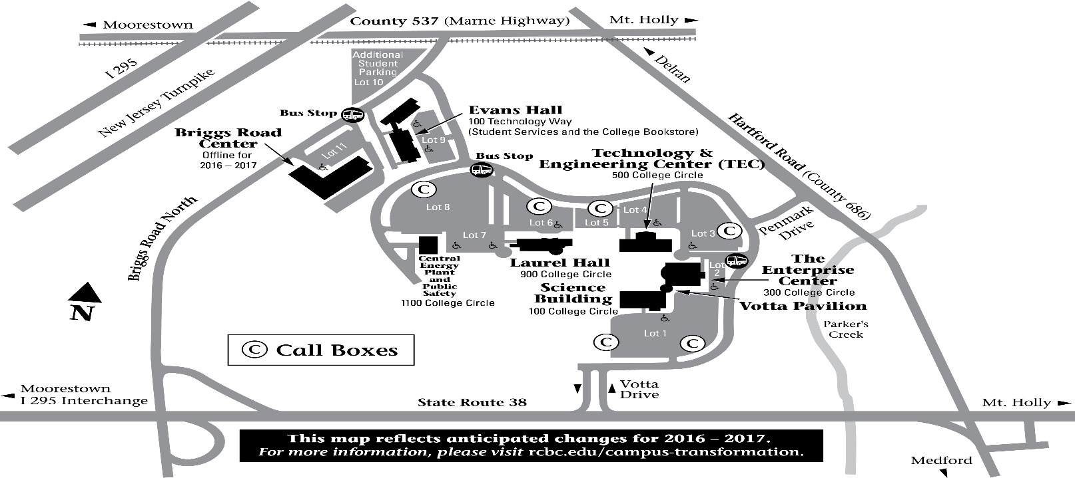

The Mt. Laurel Campus is located on Route 38 between Hartford Road and Briggs Road.
EZ Access by the Betsy Ross Bridge or Burlington Bristol Bridge from PA.

